Event-driven architecture

An event-driven architecture uses events to trigger and communicate between decoupled services and is common in modern applications built with microservices. An event is a change in state, or an update, like an item being placed in a shopping cart on an e-commerce website. Events can either carry the state (the item purchased, its price, and a delivery address) or events can be identifiers (a notification that an order was shipped).

Event-driven architectures have three key components:
- Event producers
- Event routers
- Event consumers

A producer publishes an event to the router, which filters and pushes the events to consumers. Producer services and consumer services are decoupled, which allows them to be scaled, updated, and deployed independently.
Benefits:
- Scalable: Each component scales independently based on demand.
- Flexible: Easy to add, remove, or modify components without affecting others.
- Loosely Coupled: Services communicate via events, not direct calls.
- Real-Time Processing: Responds instantly to events or user actions.

Work Flow
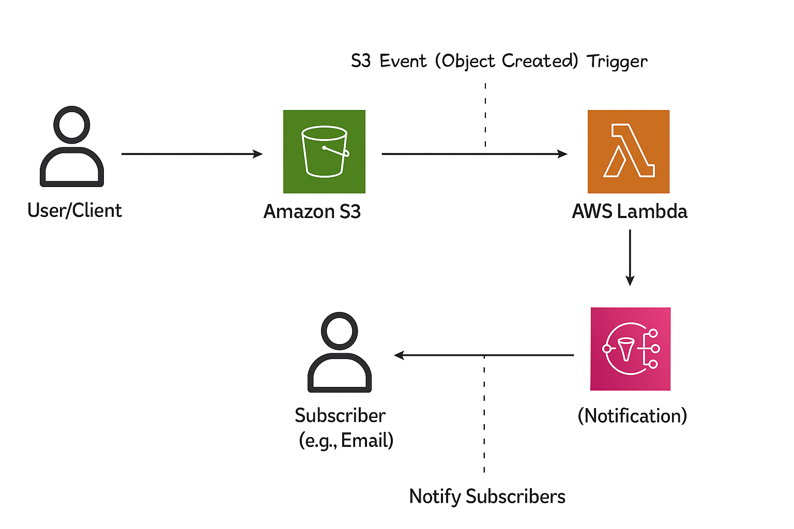
Steps:
Step 1: Sign in or create a new AWS account
Step 2: Set up an Amazon S3 bucket to store files
Step 3: Create an Amazon SNS topic for notifications
Step 4: Add a subscription to the SNS topic (e.g., email)
Step 5: Create a new AWS Lambda function
Step 6: Configure an S3 trigger to invoke the Lambda function
Step 7: Write and upload the Lambda function code
Step 8: Run an initial test of the setup
Step 9: Assign the necessary IAM permissions to Lambda and other resources
Step 10: Re-test the complete workflow to verify everything works correctly

